Ideation Phase

Define the Problem Statements

|  |  |
| --- | --- |
| Date | 19 September 2022 |
| Team ID | PNT2022TMID49101 |
| Project Name | Project - Smart Waste Management System For Metropolitan Cities |
| Maximum Marks | 2 Marks |

# Customer Problem Statement Template:

Create a problem statement to understand your customer's point of view. The Customer Problem Statement template helps you focus on what matters to create experiences people will love.

A well-articulated customer problem statement allows you and your team to find the ideal solution for the challenges your customers face. Throughout the process, you’ll also be able to empathize with your customers, which helps you better understand how they perceive your product or service.

|  |  |  |
| --- | --- | --- |
| **I am** I | Describe customer  With 3-4 key  Charactertics –  Who are they? | customer |
| **I’m trying to** | Let there outcome  Or “job”they come about.what are the trying to achieve? | Overflow with trash or recycling and before infestation becomes an issue. |
| **But** | Describe what problem or barriers in the way – what bothers them most? | Environmental concerns ,poverty reduction and employment generation. |
| **Because** | Enter the “root cause”of why the problem or barrier exists – what needs to be solved? | One of the ways to put that plan into action is through the 3 smart ideas of waste management – Reduce,Reuse,Recycle. |
| **Which makes me feel** | Describe the emotions from the customer’s point of view – how does it impact them emotionally? | Recyclables and distributed throughput the city and collection of recyclables and other materials is complicated. |

# Example:

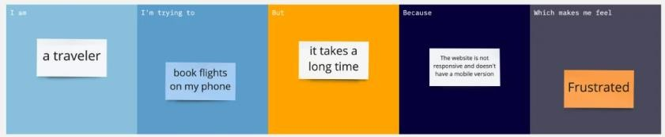

|  |  |  |  |  |  |
| --- | --- | --- | --- | --- | --- |
| **Problem**  **Statement (PS)** | **I am**  **(Customer)** | **I’m trying to** | **But** | **Because** | **Which makes me feel** |
| PS-1 | customer | Overflow with trash or recycling and before infestation becomes an issue | Environmental concerns ,poverty reduction and employment generation | One of the ways to put that plan into action is through the 3 smart ideas of waste management – Reduce,Reuse,  Recycle. | Recyclables and distributed throughput the city and collection of recyclables and other materials is complicated |
|  |  |  |  |  |  |